PMI-NEW Mentor Guide
Welcome to the Mentoring Program

This Program was established to provide members with networking opportunities and potential mentoring partnerships. This guideline will help promote a common understanding among participating Mentoring Program members and provide recommendations to help you establish a successful collaboration.

The goals of the Mentoring Program are to promote the discussion of project management concerns, to build upon our common knowledge, and support individual development via professional partnerships.

Mentorship benefits may include:
- Making connections, providing visibility, promoting career development/growth
- Discussing Job skills, industry knowledge, management and communication skills
- Guidance in problem solving and career goal setting

When learning and sharing knowledge all party’ benefits. Mentors may see the following opportunities:
- Increase their mentoring skills to use in numerous personal and professional areas
- Learn new technical knowledge, skills, competency and confidence. Pass on years of experience
- Increase professional network by developing new professional contacts
- Gain satisfaction from contributing to the development of project managers
- Achieve enhanced reputation as skilled Project Manage
- Broaden perspective, enhance challenges and interests
- PDU’s, 1 per hour of mentoring

The Mentor and Mentee should agree at the start of the mentoring partnership which parts of this guideline to follow. Throughout this partnership, please consider reviewing the guidelines periodically and provide feedback sent to the Mentoring Program Manager which will be used to improve the PMI-NEW Mentoring Program. If you have any questions at any time, please contact the Mentorship Director at dir-mentorship@pmi-new.org.

Getting Started

Prior to your first meeting
- The Mentor and Mentee will input their bio information into the PMI-NEW Mentorship intake
- The PMI-NEW Mentorship Director will review the information with an appropriate Mentee
- When a match is made, the Mentee and Mentor will obtain and review each other’s bio
- The Mentor will look at open calendar dates to meet and draft mentoring goals.
- The Mentee should reach out to establish contact and schedule a meeting preferably face2face
- If the Mentee doesn’t initiate contact the Mentor can reach out and schedule a meeting in a public location

During the first meeting
- Introductions will be made and backgrounds discussed. Contact information shared.
- The Mentee will guide the discussion flow articulating their SMART goals (Specific, Measurable, Attainable, Relevant and Timely)
- The mentee will inquire further about the Mentee’s background, work interests and motivation
- The Mentor will explain their role and work experience
- Both will agree on the ground rules for the relationship including confidentiality and sharing business information
- Both will discuss how often to meet, the pace, length and the type of meetings (face2face, phone, email, etc.)
- Scope and boundaries of what communication is appropriate (i.e. calling the mentor at home, evenings, weekends)
- Open the conversation up for general questions or thoughts
- Discuss next steps, feedback for improvement and any preparation required for the next meeting

End of each meeting
- Ask the Mentee to articulate what was discussed. What was the most important.
- What surprises were discussed and what to look for going forward
- Discuss and decide on a Mentee action plan and timeline
- Remind the Mentee to send an email summarizing the meeting and agreed upon action steps
- Schedule a time for the next meeting

The Conversation

Your time with the Mentee is to review their agenda, what has changed and why, what has the Mentee was able to accomplish, what intervened, etc. Active listening is critical as your Mentee is getting advice from a variety of sources and will look to you as a confidant having their best interests at heart.

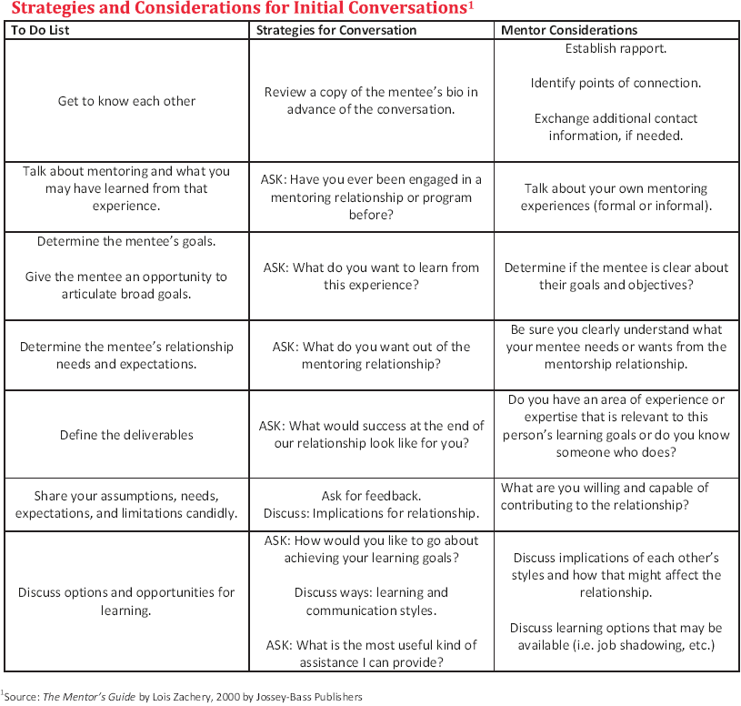

Tools
Communication skills will play a major role in how this relationship in how this relationship develops and progresses.

Feedback
Giving/receiving feedback is central to the mentoring relationship. This is an important development tool to raise awareness of specific behaviors and their impact to others in addition to modifying those behaviors when necessary.

Pitfalls/Remedies
Any good Mentor/Mentee relationship will have occasional roadblocks. Below are some examples and suggested remedies to address them:

Pitfalls | Suggested Remedies
Unrealistic Expectations | Discuss expectations and reach agreement on expected outcomes
Differences of style, age gets in the way | Take time to understand your Mentor/Mentee. Learning to work with those differences is valuable development. Consider differences as a meeting topic for discussion.
Relationship gets off track | Use good feedback skills to raise issues in a non-threatening way. Build open communication. Refocus and reiterate mentoring goals.
Relationship is not a fit | Reach out to the PMI-NEW director at Dir-Mentorship@pmi-new.org for support and advice; in some cases, it may make sense to assign a new Mentee.

Suggestions/Recommendations
- Use your best judgement to keep personal and sensitive business information confidential
- Try to have at least one face2face meeting with the Mentee
- Be prepared to provide updates on how you think the process is going and can be improved
- Contact the Mentoring Director if there are conflict of interests or the partnership is at risk due to constraints
- If the relationship is not working ask to have a different Mentor appointed
- Identify areas of Project Management that may be of interest to the Mentee

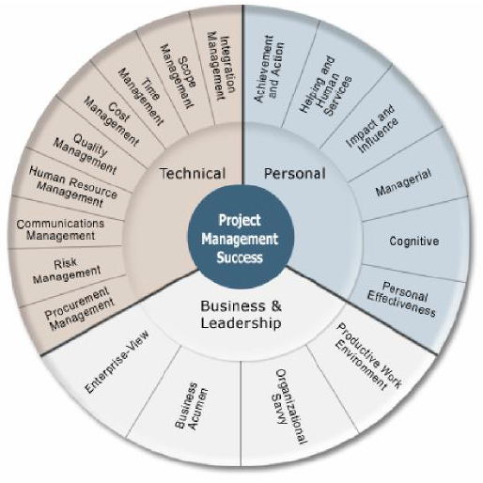

Closure
Coming to a close may present the greatest challenge for mentoring partners. It is difficult to plan for closure because relationships can end earlier or last longer then anticipated. Closure involves evaluating, acknowledging and celebrating achievement of learning outcomes. When closure is viewed as an opportunity to evaluate personal learning and apply that learning to other relationships and situations, Mentors can leverage their learning and growth to reap the full potential of the relationship. Now is a time to celebrate the journey you and your Mentee have taken.

Final Conversation Script
The ultimate intent is to have the mentee establish what was successful and to have them feel validated in the decisions made during the relationship.

The following are some examples of questions that may be appropriate:
- What were some of the conversations that you remember?
- What were some of the decisions made?
- What excited you about our time together?
- What was the high point?
- What was the biggest surprise?
- What was frustrating?
- What could have been improved?
- What have you learned that you can apply to your future?
- What was accomplished?
- How has this prepared you to identify and nurture future Mentors?

Mentor Tip Sheet

Listening
- Actively listen to your Mentee and seek to understand what your Mentee needs from you.

Giving Advice
- You are there to help but it is not your journey. Do not be offended if your advice is not
- always followed.
- Keep the partnership light and friendly. Do not add to the pressures that the person you
- are mentoring may already be under.
- Provide advice and guidance only within your area of expertise. If you aren't sure, refer
- the question to the Mentoring Program Manager.
- Try to back up your advice with where you learned it from; books, life experience,
- seminar, a former Mentor, etc. This helps guide your Mentee on ways to learn new skills.
- The Mentee needs encouragement. Remind the Mentee that being mentored means
- embracing change.
- Be prompt at returning calls or answering memos from the person you are mentoring.
- Proceed at a pace dictated by the person you are mentoring.
- Always treat any contact with a stranger with care until you feel comfortable with the
- partnership. As in any situation, do not give out personnel details beyond those that are
- necessary to the task in hand.
- Celebrate success!

DISCLAMER
PMI-NEW provides no guarantees regarding the Mentee's career growth prospects. Those outcomes are the responsibility of the Mentees and not of the Mentor or PMI-NEW.
AGREEMENT FORM

This mentoring network is sponsored by the PMI-NEW (Northeast WI) Chapter and designed to enhance the professional experience and development of the participants. Participation is strictly voluntary and without financial compensation. Please read the following guidelines regarding participation in the mentoring program. Your signature at the bottom of this agreement signifies your acceptance of the terms and conditions that govern participation in the network.
- The duration of a topical mentoring session(s) could be for a short period of one or a few days of calls or meetings. A more formal and longer term mentoring relationship between participants in the network could be from a few weeks or months to several months. Mentor and Mentee agree to actively participate in the network for the full duration of their engagement. Both will complete/return Periodic Feedback Forms to the Mentoring Program Manager.
- Mentor and Mentee agree to be available, responsive to each other's needs and willing to adjust schedules as necessary in order to achieve the minimum number of contact hours described below.
- As part of the PMI-NEW (Northeast WI) Mentoring Program, Mentor and Mentee agree to establish "live contact" for a minimum of 2 (two) contact hours each month. Four (4) contact hours each month is advised. It is recommended that the minimum contact hours be spread across and composed of (at least) two separate and distinct sessions each month. Live contact, as it is defined for this network includes (and may not be limited to): face- to-face meetings, telephone conversations, video conferences, voice-only conference calls, email, Voice-over-Internet conversations, online chats, video, or live messaging via the Internet.
- Participants are responsible for completing the program’s paperwork to establish a “mentoring partnership” prior to the initial contact with their “partner” (Mentor or Mentee).
- Information shared between the participants within the context of the formal mentoring partnership is considered confidential and should not be shared outside the relationship without expressed permission from the other participant(s).
- An individual pairing of Mentor and Mentee may prove to be unworkable or unsatisfactory to either/both participants. At any point during the “mentoring partnership”, either participant (or both) may request to dissolve the “mentoring partnership” and request a different "partner". The Mentoring Program Manager will address and resolve the pairing as quickly as possible, with no fault assigned to either party.
- A Mentor’s role is limited to the furnishing of opinions, guidance, advice and suggestions. Mentees should take all information given by a Mentor under advisement in making personal, professional and career decisions.
- It is the responsibility of the Mentor to ensure that all opinions, guidance, advice and suggestions provided as part of the formal mentoring partnership, are accurate to the best of their knowledge and do not recommend or suggest course(s) of actions for the Mentee that could be construed as illegal, unethical, or immoral.
- Participants accept responsibility for any costs incurred as part of the formal relationship, including, but not limited to: postage, telephone calls, travel, meals, conference/seminar registration, etc.
- Individuals are permitted to take part in the PMI-NEW (Northeast WI) Mentoring Program upon acknowledgment and acceptance of these terms and conditions as indicated by their signature below.
- Participant is a current member of the PMI-New chapter (with dues current).
- Please note that Mentors are volunteers and are not experts or paid consultants. Mentors, PMI-NEW (Northeast WI) and the Project Management Institute are not responsible for business, career, personal or other decisions made as a result of the mentoring partnership. Mentors give only advice and/or information from their experience, perspective, etc. Mentors do not make decisions for Mentees. PMI®, PMI-NEW (Northeast WI) and Mentors do not accept any responsibility for decisions made by Mentees.
- By entering into the Mentoring Program, the participants agree that neither PMI, PMI-NEW, nor other participants are liable for the guidance, suggestions and/or advice provided to them during the formal relationship.
- Mentor/Mentee agrees to indemnify, defend, and hold PMI-NEW (Northeast WI), PMI, all elected officers and volunteers harmless against any loss, damage, expense, or cost, including reasonable attorneys’ fees, arising out of any claim, demand, or suit asserting any losses or damages pursuant to participation in the PMI-NEW Mentoring Program including but not limited to claims involving the infringement any copyright, patent, trade secret, trademark, or proprietary right existing under the laws of the United States, any state or territory thereof, or any other country.

Participant Name (Please Print)

Participant Signature

Date

